**Assignment-22.1:**

**Write a Wordcount program and Store the result in Mysql db.**

Driver Class:

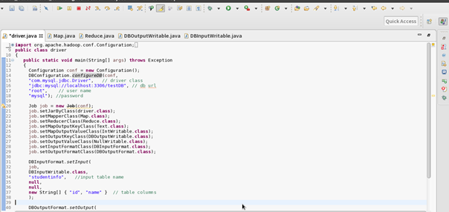

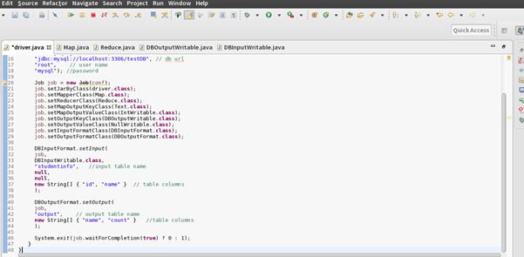

Mapper Class:

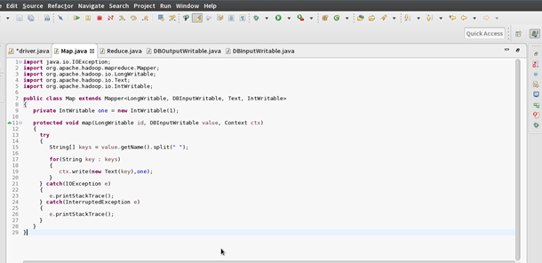

Reducer Class:

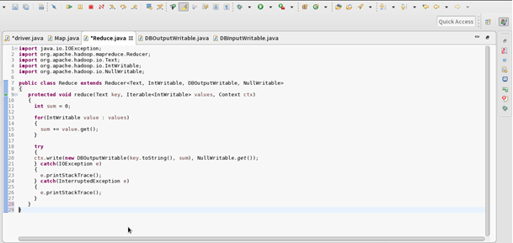

DBInputWritable Class:

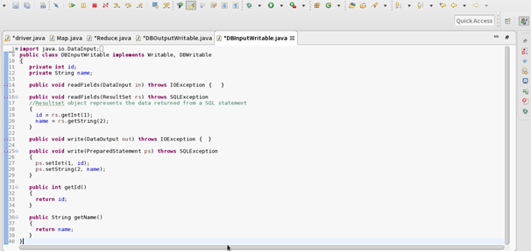

DBOutputWritable Class:

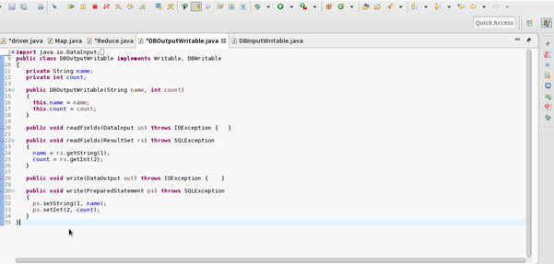

Mysql Databases and tables:

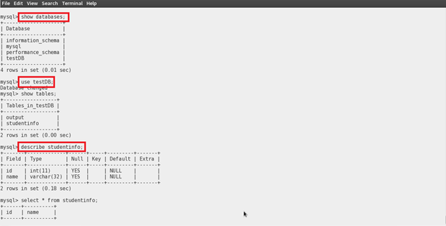

Input table:

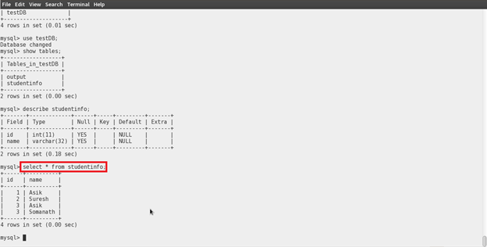

In the table studentinfo table, the number of words are counted

Running the jar file:

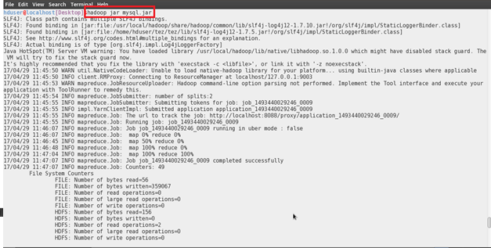

WordCount Output:

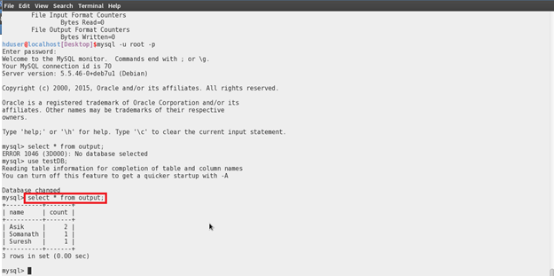

In the above screenshot, we can see that the words are counted and stored.